**REST API Design for Project Service**

This document details about the high-level design document for implementing Project

Service using REST API,

**Tech Stack:**

1. Java 8
2. Spring Boot Framework
3. Spring Security
4. Spring Data JPA
5. H2 Database
6. Mapstruct
7. JSON
8. SL4J

**Database Configuration:**

Create following Entities in H2 Database,

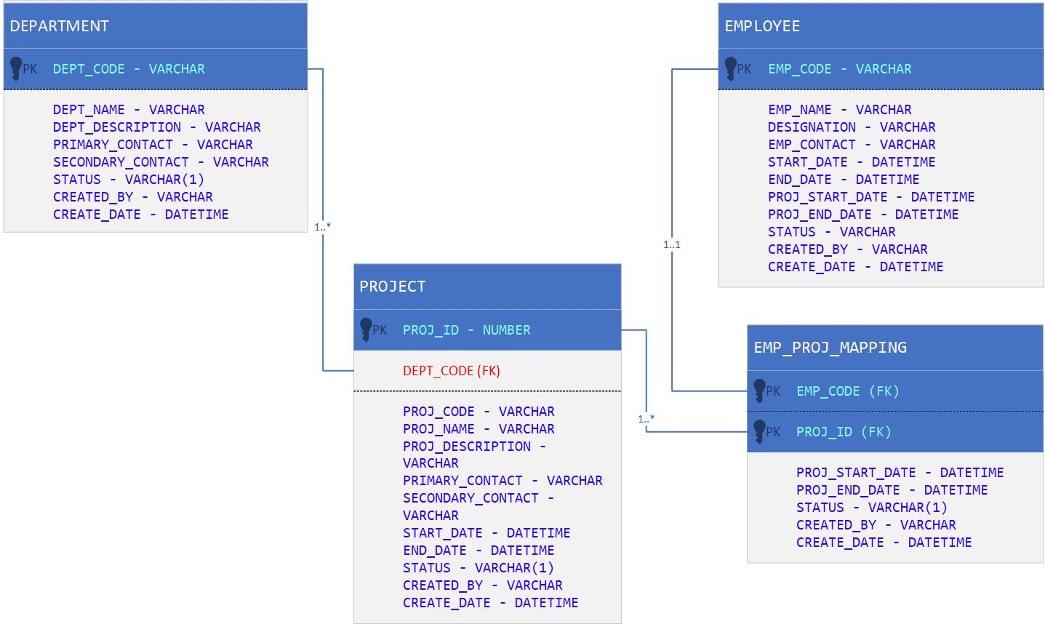

**DB Scripts**

** **

**REST API Implementation**

Create new Project REST service using Spring Boot framework with following API’s,

|  |  |
| --- | --- |
| Base URI | /project/v1/ |
| HTTP Method | GET |
| Authentication | Basic |
| URI Mapping with PathVariable | /employee/{projectCode} |
| projectCode | To retrieve the employee details for the given project code – M (Mandatory) |
| Response | It will contain the list of project details associated for the department along with the list of employees associated with the project |
| Response JSON Schema |  |
| Sample Response |  |
| Response Mapping | Use Mapstruct API to map the Source Project object received from database to the Target GetProjectResponse object |

**Sequence Diagram:**

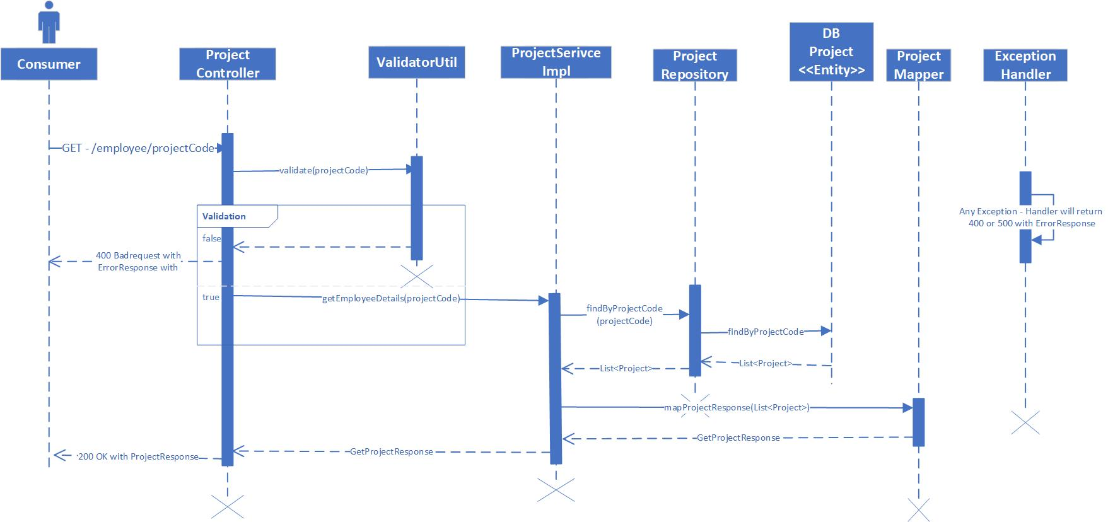

|  |  |
| --- | --- |
| Base URI | /project/v1/ |
| HTTP Method | PUT |
| Authentication | Basic |
| URI Mapping with PathVariable | /employee/{departmentCode}/{projectCode}/{employeeCode} |
| projectCode | Project Code for the given Project – M (Mandatory) |
| departmentCode | Department Code associate for the project – M (Mandatory) |
| employeeCode | Employee Code associate for the – M (Mandatory) |
| Response | Employee entity object has projectEndDate and Status  Update the projectEndDate to currentDate -1 and status = ‘**I**’ |
| Response JSON Schema |  |
| Sample Response |  |
| Response Mapping | Set the Status to “Success” |

**Sequence Diagram:**

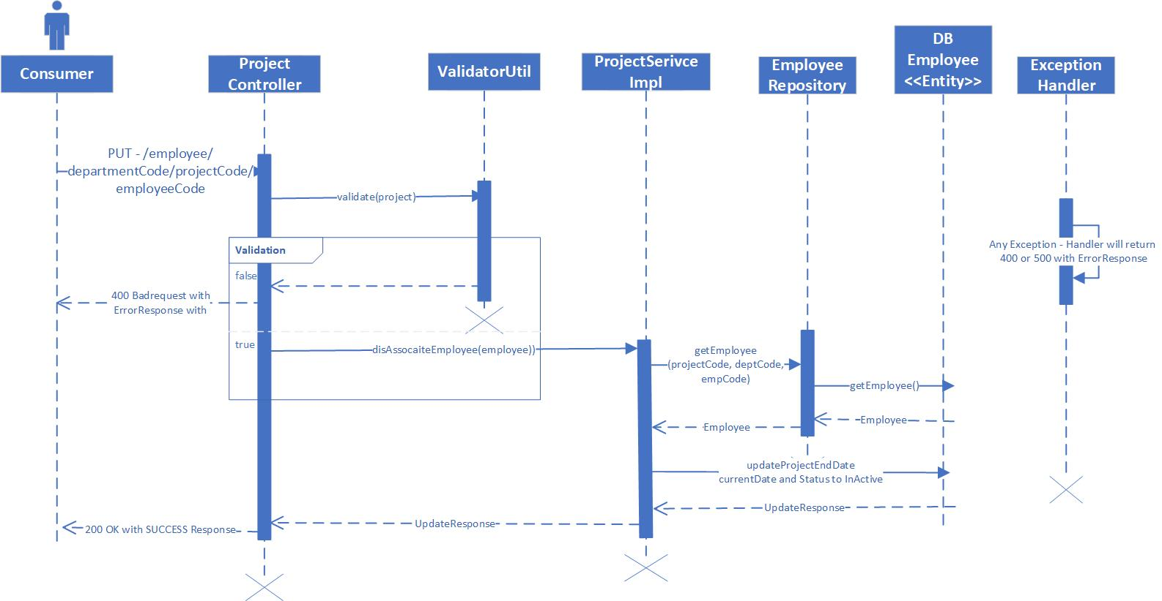

**HTTP status code and reason**

Incase of failure, set the STATUS to “Failed” and capture the Error_Code and Error_Message as part of the final UpdateResponse,

|  |  |  |  |
| --- | --- | --- | --- |
| **HTTP Status Code** | **Status** | **Error Code** | **Error Message** |
| 200 | SUCCESS |  |  |
| 400 | FAILED | BUSINESS_ERROR | Bad Request with the missing mandatory fields |
| 401 | FAILED | TECHNICAL_ERROR | Unauthorized - The authorization token in the header couldn't be validated or is missing. |
| 404 | FAILED | TECHNICAL_ERROR | Not Found - The requested resource was not found on the server. |
| 500 | FAILED | INTERNAL_SERVER_ERROR | Exception while processing with exception message |